Visual Programming

# Aaira Wajahat Rao

# 233757

# BSCS(B)

**Lab_2**

**Exercise:1**

Develop a console based application using visual c# to print your name, address and registration number.

**Input:**

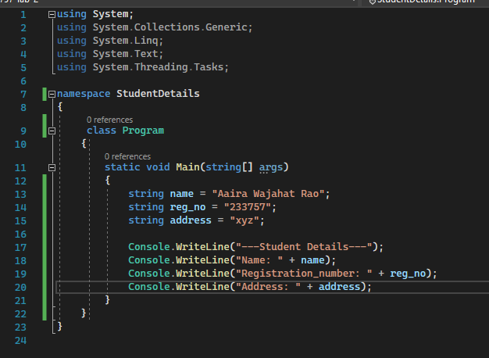

**Output:**

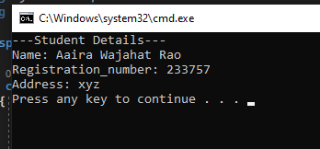

**Exercise:2**

Develop a console based application which takes command line arguments and print them on console:

**Input:**

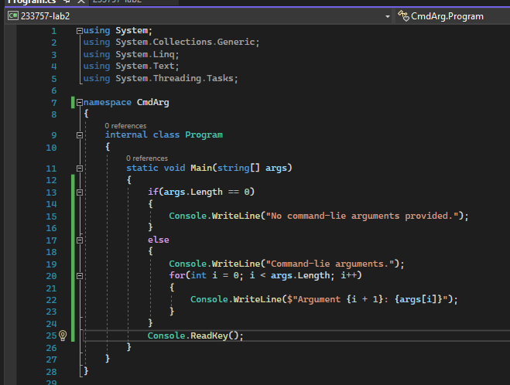

**By a , b , c:**

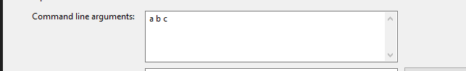

**Output:**

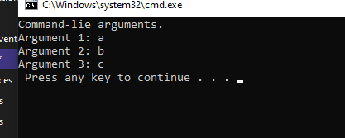

**By one two:**

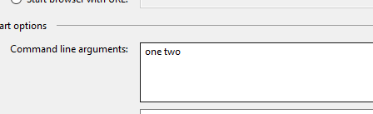

**Output:**

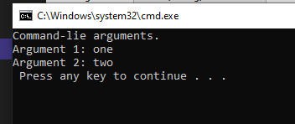

**By one two three:**

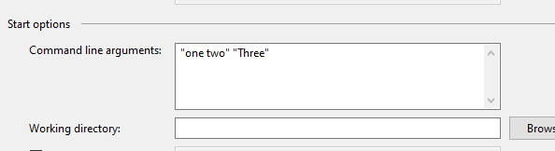

**Output:**

